LAPORAN RANCAMGAN PEMBUTAN APLIKASI

PEMROGRMAN BERDASARKAN OBJEK



Di susun oleh :

Selfia carolin pasaribu

202013013

PROGRAM STUDI TEKNIK INFORMATIKA

POLITEKNIK KAMPAR

2021

Aplikasi ini bernama aplikasi imajinasiyang di buat untuk memenuhi standarisasi teknologi di era globalisai 4.0. seiring perkembangan zaman banyak seklai nahkan sebagian besar anak-anak di seluruh dunia sudah menggunakan gadget/hadphone dalam kehidupan sehari-hari bahkan hampir sepanjang hari anak di temani oleh gadget. Berdasarkaan hal tersebut saya terinspirasi untuk membuat aaplikasi belajar seorang anak. Kenapa? Karena pada saat seorang anak sudah main mereka cenderung lupa bahkan waktu belajarpun tersita. Jadi, aplikasi ini di buat untuk meningkatkn semangat belajar anak saat menggunakan gadget. Dan mengingatkan anak agar tdak lupa waktu belajar.

Struktur navigasi

Tampilan menu

Tampilan aplikasi

Aplikasi permainan puzzle kata

Mulai Game

gampang

susah

Acak lagi

Ulangi permainan

level

B

Z

SUSAH

GAMPANG

MULAI GAME

B

END

ULANGI PERMAINAN

PILIHAN MENU

LEVEL

TAMPILAN APLIKASI

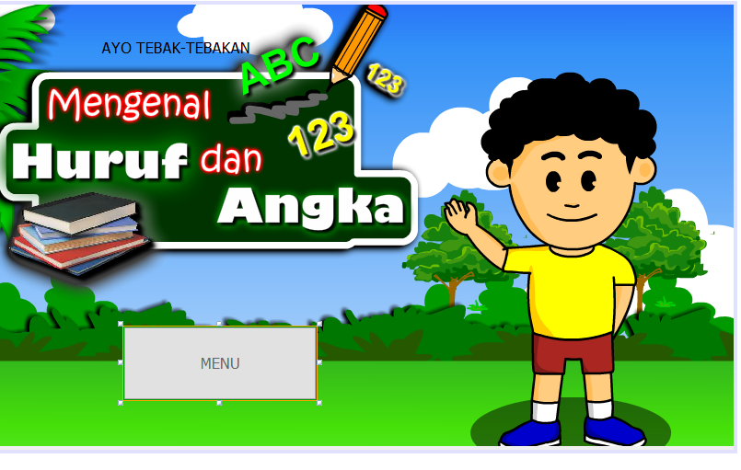

/*

* To change this license header, choose License Headers in Project Properties.

* To change this template file, choose Tools | Templates

* and open the template in the editor.

*/

/**

*

* @author User

*/

public class menu extends javax.swing.JFrame {

/**

* Creates new form NewJFrame

*/

public menu() {

initComponents();

}

/**

* This method is called from within the constructor to initialize the form.

* WARNING: Do NOT modify this code. The content of this method is always

* regenerated by the Form Editor.

*/

@SuppressWarnings("unchecked")

// <editor-fold defaultstate="collapsed" desc="Generated Code">

private void initComponents() {

jLabel1 = new javax.swing.JLabel();

jButton1 = new javax.swing.JButton();

latar = new javax.swing.JLabel();

setDefaultCloseOperation(javax.swing.WindowConstants.EXIT_ON_CLOSE);

getContentPane().setLayout(null);

jLabel1.setText("AYO TEBAK-TEBAKAN");

getContentPane().add(jLabel1);

jLabel1.setBounds(116, 37, 162, 20);

jButton1.setBackground(new java.awt.Color(0, 153, 0));

jButton1.setForeground(new java.awt.Color(102, 102, 102));

jButton1.setText("MENU");

jButton1.addActionListener(new java.awt.event.ActionListener() {

public void actionPerformed(java.awt.event.ActionEvent evt) {

jButton1ActionPerformed(evt);

}

});

getContentPane().add(jButton1);

jButton1.setBounds(140, 350, 210, 80);

latar.setHorizontalAlignment(javax.swing.SwingConstants.RIGHT);

latar.setIcon(new javax.swing.ImageIcon(getClass().getResource("/1.png"))); // NOI18N

getContentPane().add(latar);

latar.setBounds(0, 0, 810, 480);

pack();

}// </editor-fold>

private void jButton1ActionPerformed(java.awt.event.ActionEvent evt) {

new tampilanmenu().setVisible(true);

}

/**

* @param args the command line arguments

*/

public static void main(String args[]) {

/* Set the Nimbus look and feel */

//<editor-fold defaultstate="collapsed" desc=" Look and feel setting code (optional) ">

/* If Nimbus (introduced in Java SE 6) is not available, stay with the default look and feel.

* For details see http://download.oracle.com/javase/tutorial/uiswing/lookandfeel/plaf.html

*/

try {

for (javax.swing.UIManager.LookAndFeelInfo info : javax.swing.UIManager.getInstalledLookAndFeels()) {

if ("Nimbus".equals(info.getName())) {

javax.swing.UIManager.setLookAndFeel(info.getClassName());

break;

}

}

} catch (ClassNotFoundException ex) {

java.util.logging.Logger.getLogger(NewJFrame.class.getName()).log(java.util.logging.Level.SEVERE, null, ex);

} catch (InstantiationException ex) {

java.util.logging.Logger.getLogger(NewJFrame.class.getName()).log(java.util.logging.Level.SEVERE, null, ex);

} catch (IllegalAccessException ex) {

java.util.logging.Logger.getLogger(NewJFrame.class.getName()).log(java.util.logging.Level.SEVERE, null, ex);

} catch (javax.swing.UnsupportedLookAndFeelException ex) {

java.util.logging.Logger.getLogger(NewJFrame.class.getName()).log(java.util.logging.Level.SEVERE, null, ex);

}

//</editor-fold>

/* Create and display the form */

java.awt.EventQueue.invokeLater(new Runnable() {

public void run() {

new menu().setVisible(true);

}

});

}

// Variables declaration - do not modify

private javax.swing.JButton jButton1;

private javax.swing.JLabel jLabel1;

private javax.swing.JLabel latar;

// End of variables declaration

}

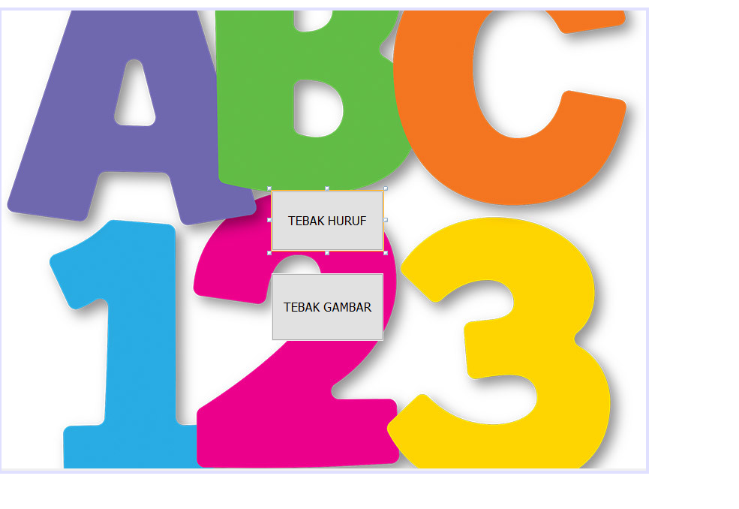

/*

* To change this license header, choose License Headers in Project Properties.

* To change this template file, choose Tools | Templates

* and open the template in the editor.

*/

/**

*

* @author User

*/

public class NewJFrame1 extends javax.swing.JFrame {

/**

* Creates new form NewJFrame1

*/

public NewJFrame1() {

initComponents();

}

/**

* This method is called from within the constructor to initialize the form.

* WARNING: Do NOT modify this code. The content of this method is always

* regenerated by the Form Editor.

*/

@SuppressWarnings("unchecked")

// <editor-fold defaultstate="collapsed" desc="Generated Code">

private void initComponents() {

jButton1 = new javax.swing.JButton();

jButton2 = new javax.swing.JButton();

jLabel1 = new javax.swing.JLabel();

setDefaultCloseOperation(javax.swing.WindowConstants.EXIT_ON_CLOSE);

getContentPane().setLayout(null);

jButton1.setText("TEBAK HURUF");

jButton1.addActionListener(new java.awt.event.ActionListener() {

public void actionPerformed(java.awt.event.ActionEvent evt) {

jButton1ActionPerformed(evt);

}

});

getContentPane().add(jButton1);

jButton1.setBounds(360, 240, 149, 80);

jButton2.setText("TEBAK GAMBAR");

getContentPane().add(jButton2);

jButton2.setBounds(360, 350, 149, 90);

jLabel1.setIcon(new javax.swing.ImageIcon(getClass().getResource("/aaaaa.jpg"))); // NOI18N

jLabel1.setText("jLabel1");

getContentPane().add(jLabel1);

jLabel1.setBounds(-10, -70, 870, 680);

pack();

}// </editor-fold>

private void jButton1ActionPerformed(java.awt.event.ActionEvent evt) {

new tebakhuruf().setVisible(true);

}

/**

* @param args the command line arguments

*/

public static void main(String args[]) {

/* Set the Nimbus look and feel */

//<editor-fold defaultstate="collapsed" desc=" Look and feel setting code (optional) ">

/* If Nimbus (introduced in Java SE 6) is not available, stay with the default look and feel.

* For details see http://download.oracle.com/javase/tutorial/uiswing/lookandfeel/plaf.html

*/

try {

for (javax.swing.UIManager.LookAndFeelInfo info : javax.swing.UIManager.getInstalledLookAndFeels()) {

if ("Nimbus".equals(info.getName())) {

javax.swing.UIManager.setLookAndFeel(info.getClassName());

break;

}

}

} catch (ClassNotFoundException ex) {

java.util.logging.Logger.getLogger(NewJFrame1.class.getName()).log(java.util.logging.Level.SEVERE, null, ex);

} catch (InstantiationException ex) {

java.util.logging.Logger.getLogger(NewJFrame1.class.getName()).log(java.util.logging.Level.SEVERE, null, ex);

} catch (IllegalAccessException ex) {

java.util.logging.Logger.getLogger(NewJFrame1.class.getName()).log(java.util.logging.Level.SEVERE, null, ex);

} catch (javax.swing.UnsupportedLookAndFeelException ex) {

java.util.logging.Logger.getLogger(NewJFrame1.class.getName()).log(java.util.logging.Level.SEVERE, null, ex);

}

//</editor-fold>

/* Create and display the form */

java.awt.EventQueue.invokeLater(new Runnable() {

public void run() {

new menu().setVisible(true);

}

});

}

// Variables declaration - do not modify

private javax.swing.JButton jButton1;

private javax.swing.JButton jButton2;

private javax.swing.JLabel jLabel1;

// End of variables declaration

}

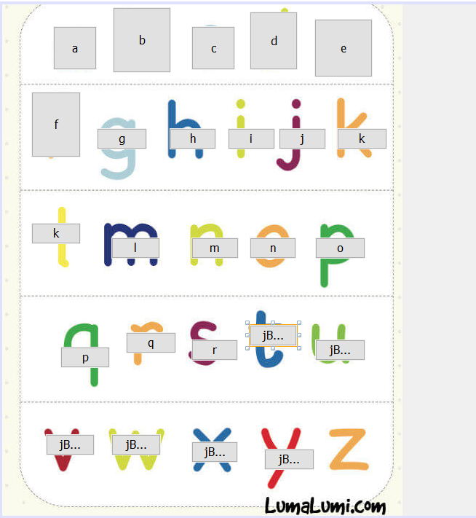

/*

* To change this license header, choose License Headers in Project Properties.

* To change this template file, choose Tools | Templates

* and open the template in the editor.

*/

/**

*

* @author User

*/

public class tebakhuruf extends javax.swing.JFrame {

/**

* Creates new form tebakhuruf

*/

public tebakhuruf() {

initComponents();

}

/**

* This method is called from within the constructor to initialize the form.

* WARNING: Do NOT modify this code. The content of this method is always

* regenerated by the Form Editor.

*/

@SuppressWarnings("unchecked")

// <editor-fold defaultstate="collapsed" desc="Generated Code">

private void initComponents() {

jButton22 = new javax.swing.JButton();

jSeparator1 = new javax.swing.JSeparator();

jButton1 = new javax.swing.JButton();

jButton2 = new javax.swing.JButton();

jButton3 = new javax.swing.JButton();

jButton4 = new javax.swing.JButton();

jButton5 = new javax.swing.JButton();

jButton6 = new javax.swing.JButton();

jButton7 = new javax.swing.JButton();

jButton8 = new javax.swing.JButton();

jButton9 = new javax.swing.JButton();

jButton10 = new javax.swing.JButton();

jButton11 = new javax.swing.JButton();

jButton12 = new javax.swing.JButton();

jButton13 = new javax.swing.JButton();

jButton14 = new javax.swing.JButton();

jButton15 = new javax.swing.JButton();

jButton16 = new javax.swing.JButton();

jButton17 = new javax.swing.JButton();

jButton18 = new javax.swing.JButton();

jButton19 = new javax.swing.JButton();

jButton20 = new javax.swing.JButton();

jButton21 = new javax.swing.JButton();

jButton23 = new javax.swing.JButton();

jButton24 = new javax.swing.JButton();

jButton25 = new javax.swing.JButton();

jButton26 = new javax.swing.JButton();

jLabel1 = new javax.swing.JLabel();

jButton27 = new javax.swing.JButton();

jButton22.setText("jButton22");

setDefaultCloseOperation(javax.swing.WindowConstants.EXIT_ON_CLOSE);

getContentPane().setLayout(null);

jButton1.setText("a");

jButton1.addActionListener(new java.awt.event.ActionListener() {

public void actionPerformed(java.awt.event.ActionEvent evt) {

jButton1ActionPerformed(evt);

}

});

getContentPane().add(jButton1);

jButton1.setBounds(70, 30, 60, 60);

jButton2.setText("b");

getContentPane().add(jButton2);

jButton2.setBounds(152, 4, 80, 90);

jButton3.setText("c");

getContentPane().add(jButton3);

jButton3.setBounds(260, 30, 60, 60);

jButton4.setText("d");

getContentPane().add(jButton4);

jButton4.setBounds(340, 10, 66, 80);

jButton5.setText("e");

getContentPane().add(jButton5);

jButton5.setBounds(429, 20, 80, 80);

jButton6.setText("f");

getContentPane().add(jButton6);

jButton6.setBounds(40, 120, 68, 90);

jButton7.setText("g");

jButton7.addActionListener(new java.awt.event.ActionListener() {

public void actionPerformed(java.awt.event.ActionEvent evt) {

jButton7ActionPerformed(evt);

}

});

getContentPane().add(jButton7);

jButton7.setBounds(130, 170, 69, 29);

jButton8.setText("h");

getContentPane().add(jButton8);

jButton8.setBounds(230, 170, 64, 29);

jButton9.setText("i");

getContentPane().add(jButton9);

jButton9.setBounds(310, 170, 65, 29);

jButton10.setText("jButton10");

jButton10.addActionListener(new java.awt.event.ActionListener() {

public void actionPerformed(java.awt.event.ActionEvent evt) {

jButton10ActionPerformed(evt);

}

});

getContentPane().add(jButton10);

jButton10.setBounds(430, 460, 69, 29);

jButton11.setText("p");

getContentPane().add(jButton11);

jButton11.setBounds(80, 470, 68, 29);

jButton12.setText("q");

getContentPane().add(jButton12);

jButton12.setBounds(170, 450, 69, 29);

jButton13.setText("r");

getContentPane().add(jButton13);

jButton13.setBounds(260, 460, 64, 29);

jButton14.setText("j");

getContentPane().add(jButton14);

jButton14.setBounds(380, 170, 65, 29);

jButton15.setText("k");

getContentPane().add(jButton15);

jButton15.setBounds(460, 170, 69, 29);

jButton16.setText("jButton16");

getContentPane().add(jButton16);

jButton16.setBounds(150, 590, 68, 29);

jButton17.setText("jButton17");

getContentPane().add(jButton17);

jButton17.setBounds(60, 590, 67, 29);

jButton18.setText("jButton18");

getContentPane().add(jButton18);

jButton18.setBounds(260, 600, 64, 29);

jButton19.setText("jButton19");

getContentPane().add(jButton19);

jButton19.setBounds(360, 610, 69, 29);

jButton20.setText("jButton20");

getContentPane().add(jButton20);

jButton20.setBounds(340, 440, 65, 29);

jButton21.setText("k");

getContentPane().add(jButton21);

jButton21.setBounds(40, 300, 68, 29);

jButton23.setText("l");

getContentPane().add(jButton23);

jButton23.setBounds(150, 320, 67, 29);

jButton24.setText("n");

getContentPane().add(jButton24);

jButton24.setBounds(340, 320, 64, 29);

jButton25.setText("o");

getContentPane().add(jButton25);

jButton25.setBounds(430, 320, 69, 29);

jButton26.setText("m");

getContentPane().add(jButton26);

jButton26.setBounds(260, 320, 65, 29);

jLabel1.setIcon(new javax.swing.ImageIcon(getClass().getResource("/ABC.jpg"))); // NOI18N

jLabel1.setText("jLabel1");

getContentPane().add(jLabel1);

jLabel1.setBounds(-20, 0, 570, 740);

jButton27.setText("jButton27");

getContentPane().add(jButton27);

jButton27.setBounds(440, 580, 70, 60);

pack();

}// </editor-fold>

private void jButton10ActionPerformed(java.awt.event.ActionEvent evt) {

// TODO add your handling code here:

}

private void jButton7ActionPerformed(java.awt.event.ActionEvent evt) {

// TODO add your handling code here:

}

private void jButton1ActionPerformed(java.awt.event.ActionEvent evt) {

// TODO add your handling code here:

}

/**

* @param args the command line arguments

*/

public static void main(String args[]) {

/* Set the Nimbus look and feel */

//<editor-fold defaultstate="collapsed" desc=" Look and feel setting code (optional) ">

/* If Nimbus (introduced in Java SE 6) is not available, stay with the default look and feel.

* For details see http://download.oracle.com/javase/tutorial/uiswing/lookandfeel/plaf.html

*/

try {

for (javax.swing.UIManager.LookAndFeelInfo info : javax.swing.UIManager.getInstalledLookAndFeels()) {

if ("Nimbus".equals(info.getName())) {

javax.swing.UIManager.setLookAndFeel(info.getClassName());

break;

}

}

} catch (ClassNotFoundException ex) {

java.util.logging.Logger.getLogger(tebakhuruf.class.getName()).log(java.util.logging.Level.SEVERE, null, ex);

} catch (InstantiationException ex) {

java.util.logging.Logger.getLogger(tebakhuruf.class.getName()).log(java.util.logging.Level.SEVERE, null, ex);

} catch (IllegalAccessException ex) {

java.util.logging.Logger.getLogger(tebakhuruf.class.getName()).log(java.util.logging.Level.SEVERE, null, ex);

} catch (javax.swing.UnsupportedLookAndFeelException ex) {

java.util.logging.Logger.getLogger(tebakhuruf.class.getName()).log(java.util.logging.Level.SEVERE, null, ex);

}

//</editor-fold>

/* Create and display the form */

java.awt.EventQueue.invokeLater(new Runnable() {

public void run() {

new tebakhuruf().setVisible(true);

}

});

}

// Variables declaration - do not modify

private javax.swing.JButton jButton1;

private javax.swing.JButton jButton10;

private javax.swing.JButton jButton11;

private javax.swing.JButton jButton12;

private javax.swing.JButton jButton13;

private javax.swing.JButton jButton14;

private javax.swing.JButton jButton15;

private javax.swing.JButton jButton16;

private javax.swing.JButton jButton17;

private javax.swing.JButton jButton18;

private javax.swing.JButton jButton19;

private javax.swing.JButton jButton2;

private javax.swing.JButton jButton20;

private javax.swing.JButton jButton21;

private javax.swing.JButton jButton22;

private javax.swing.JButton jButton23;

private javax.swing.JButton jButton24;

private javax.swing.JButton jButton25;

private javax.swing.JButton jButton26;

private javax.swing.JButton jButton27;

private javax.swing.JButton jButton3;

private javax.swing.JButton jButton4;

private javax.swing.JButton jButton5;

private javax.swing.JButton jButton6;

private javax.swing.JButton jButton7;

private javax.swing.JButton jButton8;

private javax.swing.JButton jButton9;

private javax.swing.JLabel jLabel1;

private javax.swing.JSeparator jSeparator1;

// End of variables declaration

}